

Schools must use the funding to make additional and sustainable improvements to the quality of PE and sport they offer. This means that you should use the Primary PE and Sport Premium to:

- develop or add to the PE and sport activities that your school already offers
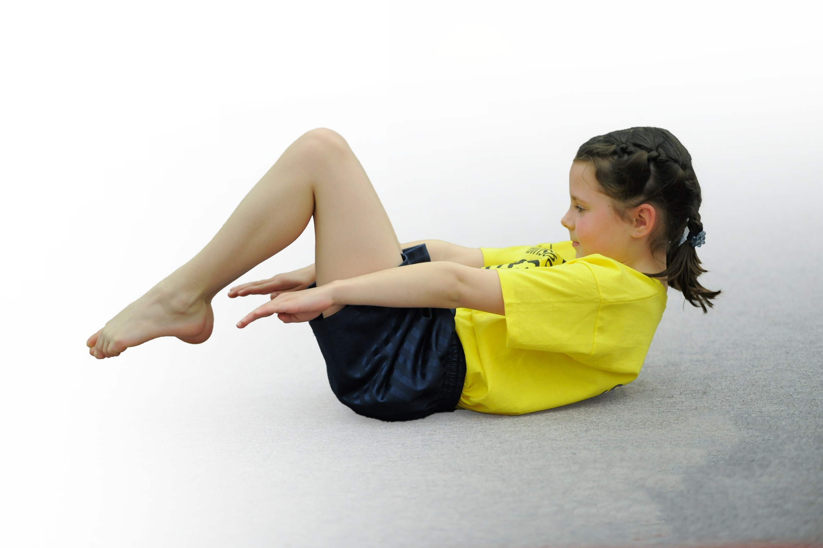
- build capacity and capability within the school to ensure that improvements made now will benefit pupils joining the school in future years

Please visit gov.uk for the revised DfE guidance including the 5 key indicators across which schools should demonstrate an improvement. This document will help you to review your provision and to report your spend. DfE encourages schools to use this template as an effective way of meeting the reporting requirements of the Primary PE and Sport Premium.

We recommend you start by reflecting on the impact of current provision and reviewing the previous spend.
Under the Ofsted Schools Inspection Framework, inspectors will assess how effectively leaders use
the Primary PE and Sport Premium and measure its impact on outcomes for pupils, and how effectively governors hold them to account
for this.

Schools are required to publish details of how they spend this funding as well as on the impact it has on pupils’ PE
and sport participation and attainment.
We recommend regularly updating the table and
publishing it on your website as evidence
of your ongoing review into how you are using the money
to secure maximum, sustainable impact. To see an example of how to complete the table please click HERE.

Support for review and reflection - considering the 5 key indicators from DfE, what development needs are a priority for your setting and your students now and why? Use the space below to reflect on previous spend, identify current need and priorities for the future.

Key achievements to date: | Areas for further improvement and baseline evidence of need:
-Achieved School Games Gold Mark for three years.  -Offer a wide variety of clubs (15 sports clubs) and this will continue.  -138 pupils have attended at least one extra-curricular physical activity club this year.  -Attend SSSP competitions.  -Increased number of level one competitions for all pupils.  -Increased confidence of the PE teacher due to CPD.  -Encouraged pupils to be active before school e.g walking.  School employs full time specialist PE teacher to lead and teach PE across school | -Introduce the ‘30:30 Active Planner’ and make all areas of the national curriculum more active.  -Re-consider ‘The Daily Mile’.  -Enter more Inclusive Competitions.  -Introduce physical activity into breakfast club or offer more morning clubs.

Meeting national curriculum requirements for swimming and water safety | Please complete all of the below*:
What percentage of your current Year 6 cohort swim competently, confidently and proficiently over a distance of at least 25 metres? | 42%
What percentage of your current Year 6 cohort use a range of strokes effectively [for example, front crawl, backstroke and breaststroke]?
What percentage of your current Year 6 cohort perform safe self-rescue in different water-based situations?
Schools can choose to use the Primary PE and Sport Premium to provide additional provision for swimming but this must be for activity over and above the national curriculum requirements. Have you used it in this way? | No- consider using funding for this
*Schools may wish to provide this information in April, just before the publication deadline.

Action Plan and Budget Tracking
Capture your intended annual spend against the 5 key indicators. Clarify the success criteria and evidence of impact that you intend to measure to evaluate for students today and for the future.

Academic Year: 2017/18 | Total fund allocated: £9,178 | Date Updated: March 2018
Key indicator 1: The engagement of all pupils in regular physical activity – Chief Medical Officer guidelines recommend that primary school children undertake at least 30 minutes of physical activity a day in school |  |  |  | Percentage of total allocation:
 |  |  |  | %
School focus with clarity on intended impact on pupils: | Actions to achieve: | Funding allocated: | Evidence and impact: | Sustainability and suggested next steps:
To engage less active/disengaged pupils and ensure they complete 30 active minutes during the school day.  Increase physical activity before school. Pupils walk to school daily.  Purchase new equipment and resources when and if required. | Introduce the 30:30 Active planner approach (heat map).  Audit the physical activity levels across the NC (not just PE lessons, break and lunch times).  School Council Members and Class Teachers daily record the results on the ‘Wow Travel Tracker’ walking, park &stride, bike and scooters.  PE teacher regularly checks equipment and will continue to purchase new equipment if required. Replace any broken or old equipment e.g Netball court markings have faded. Purchasing new netball court markings will enable regular matches and increase competitive opportunities. | Netball court markings.  Maude Sport  £1,090.85 | PE teacher to encourage staff to make all areas of the NC more active.  Pupils receive 2 hours of PE per week.  327 pupils currently walk to school. Total walks in March =2960 times.  The above pupils gain and achieve their walking to school badges (each term). Encourage disengaged pupils to take part with this.  Purchased new line marking for the KS2 yard/netball court.  Court markings will be visible which supports the pupils when playing a netball match. | -Encourage all staff to complete 30:30 active planner heat map daily for their own class and provide pupils with more opportunities to be active.  Maybe seek support from School Councilors or School Games Crew Members to complete the heat map (similar to what they do with the walking to school planner).  -Encourage more pupils to walk to school.  -Re-consider the ‘daily mile’.  -Arrange more level two netball matches.
Key indicator 2: The profile of PE and sport being raised across the school as a tool for whole school improvement |  |  |  | Percentage of total allocation:
 |  |  |  | %
School focus with clarity on intended impact on pupils: | Actions to achieve: | Funding allocated: | Evidence and impact: | Sustainability and suggested next steps:
To celebrate participation and achievements of KS1 and KS2 pupils.  To support pupils physical, psychological and emotional well-being. | PE teacher to continue adding photos on to the PE display/school newsletter/competitions/website and twitter page.  Medals for sports day (Purchased annually)  Certificates – regularly handed out during assemblies and achieved by attending competitions or clubs.  PE teacher has organised Yoga for Y6 and a specialist yoga teacher will deliver these sessions. | Medals for schools  £405.90  Active Sefton -Yoga  £180.00 | Pupils are proud to be recognized  for their sporting achievements.  Increased confidence by celebrating their achievements.  Yearly sports day  Sports trophies visible in the school’s reception.  Encourage and motivate pupils across KS1/KS2. Motivate the disengaged through other pupils’ achievements.  Hopefully, pupils will be less anxious and achieve better SATS results. | -Encourage individuals to share their sporting achievements in and outside of the school environment.  -Add outside of school sporting achievements to the PE display.  -Introduce School Games Value certificates: Respect, Resilience, Teamwork, Self Belief, Determination etc  -Continue to celebrate achievements via certificates/  medals and trophies.  -Set up the Youth Sports Trust ‘My Personal Best’ approach (level 0).  -Pupil voice – Maybe ask the pupils if they found the sessions effective and if successful consider organizing the sessions each year.

Key indicator 3: Increased confidence, knowledge and skills of all staff in teaching PE and sport |  |  |  | Percentage of total allocation:
 |  |  |  | %
School focus with clarity on intended  impact on pupils: | Actions to achieve: | Funding  allocated: | Evidence and impact: | Sustainability and suggested  next steps:
To improve the quality of teaching and learning in PE across both key stages. | Attend CPD to up skill knowledge.  Attend SSSP meetings and conferences.  Regular meetings with School Games Organiser. | Supply teacher  if required at £180 per day  South Sefton Sports Partnership  £2000 | -PE teacher more confident and supports other staff in planning and delivering physical activities.  -High quality PE lessons being delivered by the PE teacher therefore high quality learning taking place and pupils have made good progress. Pupils appear more confident and have stated that they enjoy PE lessons. | -Share knowledge to other members of staff.  -Continue to advertise CPD opportunities.  -PE teacher keep up to date with developments in PE and school sport initiatives.  -Audit staff on their CPD requirements.  -PE teacher to continue to attend SSSP CPD opportunities.
Key indicator 4: Broader experience of a range of sports and activities offered to all pupils |  |  |  | Percentage of total allocation:
 |  |  |  | %
School focus with clarity on intended  impact on pupils: | Actions to achieve: | Funding  allocated: | Evidence and impact: | Sustainability and suggested  next steps:
To provide a broader experience by offering a variety of physical activities  and new physical activities, if available.  High quality & specialist sports coaches.  Target less engaged for clubs and SEND/pupil premium pupils. | To contribute to an individual’s healthy and active lifestyle.  To target specific groups.  To encourage children to participate in a range of sports and aim to continue their enthusiasm to participate in a sport(s) throughout life.  To enhance the variety and quality of sporting opportunities for children across the school. | Leap Gymnastics & Dance  £2,460  Active Sefton- various clubs.  £480  Judo  £538  Fencing  £100 | Increased engagement in a range of physical activities.  PE teacher and specialist sports coaches deliver engaging extra-curricular clubs.  PE lead has targeted pupils to encourage them to take part in extra-curricular clubs and has explored barriers to participation.  Increased number of physical activities/clubs offered to KS1 and KS2 pupils.  46 KS1 pupils have attended clubs  23 PP KS1 pupils have attended clubs (Some students attend more than one club).  92 KS2 pupils have attended clubs  64 PP KS2 pupils who have attended clubs Some students attend more than one club). | -Continue to offer a variety of physical activities.  -Pupil voice and ask the School Games Crew Members for their opinions and ideas about what other clubs our school could offer.  -Continue to target less engaged children.  -Continue to target SEND and PP pupils.  -PE teacher advertises outside of school sport clubs or sports agencies.  -Continue to audit pupil’s interests.
Key indicator 5: Increased participation in competitive sport |  |  |  | Percentage of total allocation:
 |  |  |  | %
School focus with clarity on intended  impact on pupils: | Actions to achieve: | Funding  allocated: | Evidence and impact: | Sustainability and suggested  next steps:
To increase competitive opportunities through participation in arrange of physical activities for children of all abilities.  Funding for transport has enabled all children to take part in a wider range of quality inter-school sports competitions and team activities.  PE Teacher regularly delivers (level 1) competitions in school for KS2 pupils.  To increase pupil’s confidence when competing against other schools by wearing appropriate sports kits like others e.g football kits instead of wearing PE kits. | To participate in competitive opportunities throughout the year  and continue to fund transport costs when required, in order to take part in local and regional competitions.  End of unit competition/class tournaments (level 1).  Recognising and celebrating individuals and talented pupils.  Sign post talented students to attend clubs and local teams.  Make all pupils aware of club opportunities.  Purchase a football kit for KS1 pupils (KS2 have a football kit), try and get a similar one so both CC football kits match.  Seek to get a sponsor for the football kit. | South Sefton Sports Partnership  As above.  Bootle Boys FC District Primary School Membership  £100.00  Transport:  Coaches  £1,540  Taxis  £23.60  KS1 Football Kit  approximately  £200-300 | KS1 and KS2 children have participated in numerous competitive sporting activities during the Autumn and Spring terms. This will continue through the Summer term.  All pupils have taken part in at least two competitions. Pupil participation in level two competitions have increased by 20% over the last two years. Children are developing sporting attitudes such as resilience, teamwork, respect and this has impacted on how they work collaboratively throughout all areas of the curriculum. Children have positive attitudes towards health and wellbeing.  Annual Sports Day  KS1 football teams attended a football event at LFC wearing PE kits whereas the other schools wore their own football kits which makes the children look the part and also contributes to the team’s confidence and motivation. | -Take part in all SSSP competitions and other competitions available e.g football games/cups.  -Consider whole school competitions e.g each term for example – a rounders tournament.  -Continue to participate in SSSP competitions and deliver level 1 competitions.  -PE teacher advertises pathways to outside of school sport clubs or sports agencies  -Introduce Level 0 Personal Best.

